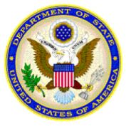 | 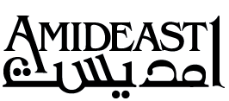 | 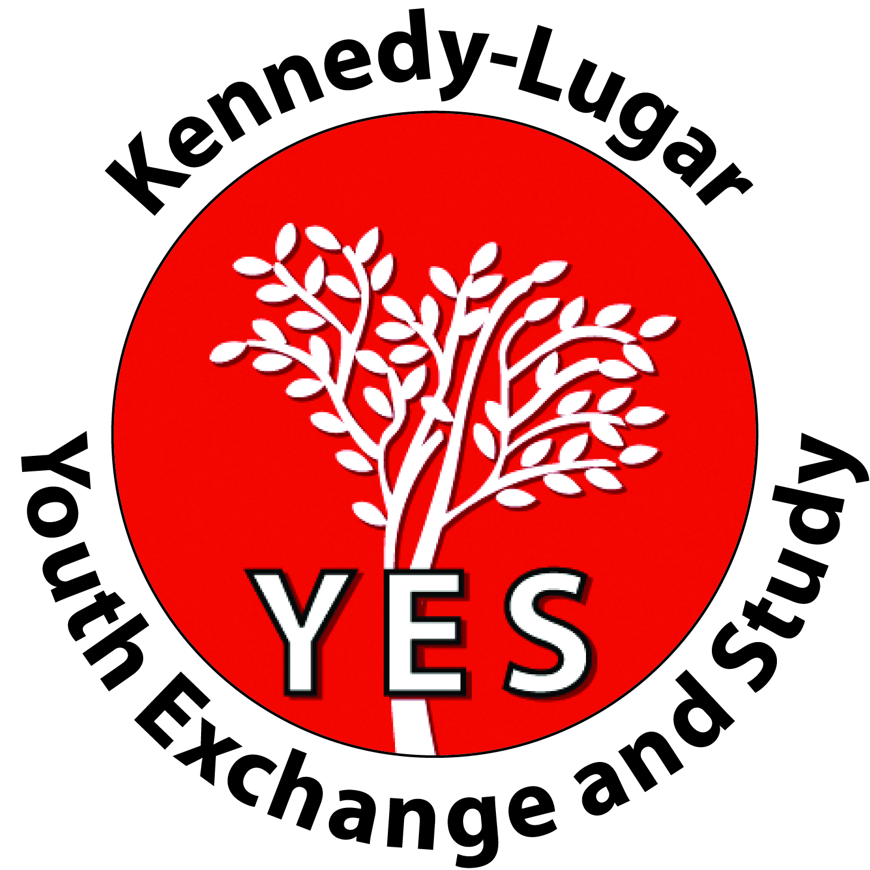
Kennedy-Lugar Youth Exchange and Study Program (YES) -
Pre-Application for 2021 -2022 Academic Year
Please complete the following form in ENGLISH.

Student full name (In English exactly as passport)
Date of Birth (DD/MM/YYYY) |  | Gender | □ Male / □ Female
Nationality: |  | City of Residence:
Father Mobile #: |  | Mother Mobile #:
Active Email address
Do you hold any other passports? | □ YES / □ NO | If YES what
Are you a U.S. citizen or do you have a U.S. passport | □ YES / □ NO | Have you ever applied for a green card or U.S. permanent residency | □ YES / □ NO
Have you ever been in the United States? | □ YES / □ NO | If yes, how many times, when, for how long?
Do any of your parents work at the U.S Embassy | □ YES / □ NO | Have you participated in the Access Microscolarship Program | □ YES / □ NO

((الرجاء تزويدنا برقم هاتف فعال و عنوان بريد الكتروني حيث سيتم التواصل معك عبر الرقم و البريد الالكتروني المذكورين في النموذج

School Name
School Type | □ Public / □ Private / □ Military / □ UNRWA
School Director’s Name |  | School Phone

Student’s Current grade level: 9th 10th

Student’s Overall Grade Average in the past two years ○ 2018-2019 _______ ○ 2019-2020 ________
Student’s English Grade Average in the past two years: ○ 2018-2019 _______ ○ 2019-2020 ________
-----------------------------------------------------------------------------------------------------------------------------------------------------------------
Parent’s Consent— To be completed by parents

My son/daughter has my permission to apply for, and to participate in the YES Program administered by AMIDEAST.

Parent/Guardian’s signature: Date:

This is the first in a series of steps for application to the YES Program. You will be contacted if you are selected for the next step, English language testing in November 2020.

Completed applications can be delivered by hand at any AMIDEAST Jordan, or by email ScholarshipsJO@amideast.org

Required attachments:
- Official final transcripts for the past two years
- Copy of your birth certificate

Application Deadline: November 1, 2020.

