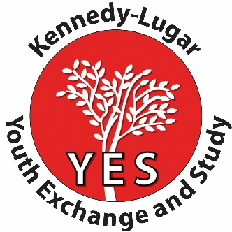

Attach a photo of you smiling here.
PRELIMINARY APPLICATION
Youth EXchange and Study Program

Be a Youth Ambassador and say YES to studying in the United States!! The Kennedy Lugar YES Program is available to Moroccan high school students, who have existing good academic credentials and English language skills. Please complete the following application in block letters and submit it before Tuesday, October 10th 2023 .

All information must be included, and please provide us with transcripts from the last two (2) years (containing both semesters) and a birth certificate for your application to be considered.

Student Name _____________________ _____________________________
Family name First Name

City of birth: _________________________________________

Nationality: _________________________________________

High School: __________________________________________

Student Address: __________________________________________

City of residence: _______________________________________________________________________

Contacts: ______________ /_______________________________/________________________
Student phone number Parent phone number Student E-mail (mandatory typed email)

Student Birth Date Day / Month / Year

(the applicants must be born between August 15, 2007 and August 15, 2009) ____ /______ /__________

Current year in high school: Tronc commun ☐ 1ère du Bac ☐

Last year’s grade averages: Moyenne Générale ______ English ______________

English Teacher: _______________________ /_______________________________
Full name School/Institution
English Teacher’ recommendation: _______________________________________________________________

Signature: ________________________________________

Parental consent to participate: __________________________________

Father’s name: ______________ Father’s signature: ______________

Mother’s name: ______________ Mother’s signature: ______________

This is the first in a series of steps for application to the Kennedy-Lugar Youth Exchange and Study program.
Successful applicants will be contacted for language testing and interview.
AMIDEAST Rabat
Address: 35, Rue Oukaimden, Agdal Rabat/ Phone: 05 37 67 50 75

AMIDEAST Casablanca
Address: Zenith 1, Etage 3, Sidi Maarouf Casablanca/ Phone: 05 22 25 93 93
Email Address: MoroccoYES@AMIDEAST.ORG
