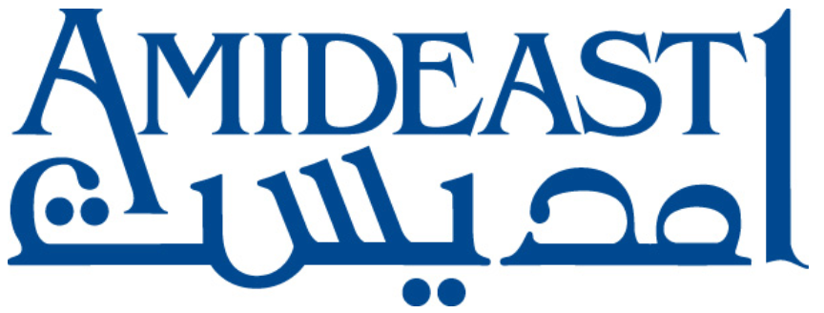

Request for Statement of Interest
Short-Term Study Abroad for Egyptian Students

U.S.-Egypt Higher Education Initiative (HEI),
Public University Scholarships Program

FUNDED BY: USAID

This is an ongoing collection of information to be used for placement of students through the Fall 2021 semester. There is no deadline for submission of statements of interest.

Under the U.S.-Egypt Higher Education Initiative Public University Scholarships program (HEI), by Fall 2021 AMIDEAST will send approximately 245 Egyptian undergraduate students to the U.S. for one semester each, and is looking to identify universities that are interested in hosting these study abroad students. This request for a statement of interest asks accredited colleges and universities to provide information about their university, programs, schedules, costs, and international student experience in order to help AMIDEAST to make decisions about placement of students in study abroad programs.
Interested institutions should submit a completed Statement of Interest Form and/or questions to:
Ahmed Shehata, ashehata@amideast.org
Please note that completion of this statement of interest does not guarantee placement of a student at a particular institution.
Further information about AMIDEAST, the expected study abroad program, and the HEI scholarship program follows.

AMIDEAST Background
AMIDEAST is a leading American non-profit organization engaged in international education, training and development activities in the Middle East and North Africa for over 60 years. AMIDEAST also possesses significant scholarship administration experience in the U.S., including the management of the Fulbright scholarship program in the U.S. Additional information about AMIDEAST can be found online at www.amideast.org.

Study Abroad Program Description
Study Abroad Participants: Approximately 245 Egyptian undergraduate students, currently studying at five public universities in Egypt on the HEI scholarship program administered by AMIDEAST will study abroad. The 245 are the top 65% of HEI scholarship students, and will include some students with disabilities. 83 students have traveled on study abroad to date.
Study Abroad Timing: Students may travel in the fall, spring, or summer semesters of their third year (and in the case of five-year degree programs, their fourth year). Although we prefer that students travel in fall and spring, a significant number of students will also travel in summer.
Study Abroad Activities: Students will live on campus and take academic courses, as well as participating in other enrichment activities on campus to possibly include community service, internships, cross-cultural engagement, or other activities. The primary focus of the study abroad program is academic (most students will be able to transfer credits to their home university in Egypt), but in particular for summer semesters, students will ideally also participate in an internship arranged by the institution. Students study in nine faculties in Egypt: Agriculture, Business, Economics, Engineering, Computer Science, Law, Mass Communication, Nursing, and Science, with Business and Engineering being the most common fields.
Logistics: AMIDEAST will coordinate the issuance of J visas through USAID, and will arrange for the students’ air travel, book costs, and stipends. The preference is for students to stay in university dormitories in a standard double room with an American roommate (or at the very least a non-Arabic-speaking roommate) and to have meal plans that cover most meals. Alternative housing arrangements are possible and can be discussed. AMIDEAST will also purchase medical insurance for the student that meets USAID ADS 252/253 and J1 visa requirements.
Expectations: In addition to the standard university activities (courses, advising, international office support, orientation), the institution is expected to support the student in registering for a full course load of credits (with the aim of enrolling in as many transferable courses as possible) and to complete a midterm assessment to ensure that students are participating fully in their program.
Process: Once students are selected for study abroad, AMIDEAST will begin to look for matches with U.S. institutions based on the institution’s required iBT score and GPA, course alignment with the home university (for transfer credits), schedule compatibility between the U.S. and home university, and cost/cost share. AMIDEAST will then contact the institution to process the student’s application. This ideally happens three to four months before the start of the semester. AMIDEAST and the institution will sign a memorandum of understanding that explains the roles and responsibilities during the study abroad program of the student.

U.S.-Egypt Higher Education Initiative (HEI) Public University Scholarships Program
Study abroad students are recipients of the U.S.-Egypt Higher Education Initiative (HEI) Public University Scholarships program, which is a scholarship for disadvantaged Egyptian high school graduates to attend excellence programs at public universities in Egypt, in parallel with specially-designed supplementary enhancement activities such as English, leadership training and career planning, as well as internships, community service, and study abroad at U.S. universities. Administered by AMIDEAST, funded by USAID, and supported by the Government of Egypt, the program interweaves the private sector and practical experiences so that graduates are primed to enter and contribute to the workforce in Egypt, in sectors that are critical to Egypt’s economic development.
The program recruits socio-economically disadvantaged men and women (including those with disabilities) from all 27 governorates of Egypt in four cohorts (in 2015, 2016, 2017, and 2018). Through a competitive, transparent application and four-stage screening process, students have been be selected for the scholarship based on academic excellence, high financial need, leadership potential, commitment, and a capacity for growth. 581 students are currently in the program, having just completed their first, second, third or fourth academic year.
The scholarship covers tuition and fees for the English-language excellence programs at Egyptian universities, as well as a parallel enhancement program designed to supplement their academics and prepare youth to obtain jobs upon graduation. Students attend one of five top public universities in Egypt (Cairo, Ain Shams, Alexandria, Mansoura, and Assiut Universities), enrolled in faculties including engineering, business administration, law, science, agriculture, commerce (business), computer science, economics, mass communication, and math and science education.
A structured extracurricular enhancement program focusing on English, character building and leadership development, academic skills, and career development/job market readiness—designed based on the needs of the labor market and consistently incorporating the private sector—complements the technical knowledge they are learning in their degree programs. The program includes over 900 hours of training as well as community service projects, student internships, and study abroad.

U.S.-Egypt Higher Education Initiative
Ultimately the scholarship program will increase access to quality education for disadvantaged youth and prepare them with the additional skills needed to increase their employability in key sectors, contributing to the economic development of Egypt. This program is part of the U.S.-Egypt Higher Education Initiative, a $250 million investment in Egypt’s future that provides educational opportunities for high-achieving Egyptians to learn skills that will better meet the needs of the 21st century economy. The Initiative encourages partnerships between Egyptian and American universities for knowledge transfer, research, and joint degree programs that reflect the needs of a modern economy in critical disciplines such as agribusiness, engineering, and entrepreneurship. It provides scholarships for talented, young Egyptians—women and men from underserved communities in rural and urban areas—to Egyptian and American universities in fields that will help them reach their aspirations and contribute to Egypt’s economic prosperity.

Thank you for your interest in hosting Egyptian students.

