Press Releases 2011

Ambassador Connelly Hosts a Reception for Students from Kennedy-Lugar Youth Exchange and Study Scholarship

July 13, 2011
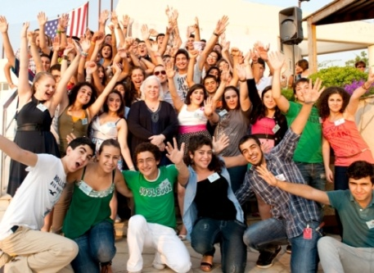

On July 9, 2011, U.S. Ambassador Maura Connelly hosted a reception for students from the Kennedy-Lugar Youth Exchange and Study Scholarship Program (YES) and their parents. This event welcomed the thirty-four returning YES students and the thirty students who will depart for the U.S. this summer. The event was an opportunity to bring past and present YES students together to meet each other and to exchange experiences, and to ask questions. Several Americans from the Embassy were at the event to talk to the students about the United States.
The Kennedy-Lugar Youth Exchange and Study (YES) program was established in March 2003 in Lebanon. Lebanese high school students, ages 14 to 16, spend one academic year in the United States. The students live with host families, attend high school, and engage in activities to learn about American society and values, acquire leadership skills, and help educate Americans about Lebanese culture.
Upon their return to Lebanon, YES students become part of an alumni program which gives them the chance to apply what they learned during their time in the United States to their home communities. The students work together to carry out community service projects and other extracurricular activities to benefit their peers and community. To date, there are 249 Lebanese YES alumni.
AMIDEAST administers the Kennedy-Lugar Youth Exchange and Study (YES) program in Lebanon and is responsible for the recruitment and selection processes, and provides the selected candidates with the necessary preparations needed for a successful cultural exchange experience. When the students are back, they become part of the YES Alumni who, guided by AMIDEAST, engage in community service projects and alumni development activities.

